



**T Y P E S O F H A R M**

**The Care Act recognises 10 categories of abuse that may be experienced by adults.**

# Self-neglect

This covers a wide range of behaviour: neglecting to care for one’s personal hygiene, health or surroundings and includes behaviour such as hoarding.

# Modern Slavery

This encompasses slavery, human trafficking, forced labour and domestic servitude.

# Domestic Abuse

This includes psychological, physical, sexual, financial and emotional abuse perpetrated by anyone within a person’s family. It also includes so called 'honour' based violence.

# Discriminatory

Discrimination is abuse which centres on a difference or perceived difference particularly with respect to race, gender or disability or any of the protected characteristics of the Equality Act.

# Organisational

This includes neglect and poor care practice within an institution or specific care setting such as a hospital or care home, for example, or in relation to care provided in one’s own home. This may range from one off incidents to on-going ill-treatment. It can be through neglect or poor professional practice as a result of the structure, policies, processes and practices within an organisation.

# Physical

This includes hitting, slapping, pushing, kicking, misuse of medication, restraint or inappropriate sanctions.

# Sexual

This includes rape, indecent exposure, sexual harassment, inappropriate looking or touching, sexual teasing or innuendo, sexual photography, subjection to pornography or witnessing sexual acts, indecent exposure and sexual assault or sexual acts to which the adult has not consented or was pressured into consenting.

# Financial or material

This includes theft, fraud, internet scamming, coercion in relation to an adult’s financial affairs or arrangements, including in connection with wills, property, inheritance or financial transactions, or the misuse or misappropriation of property, possessions or benefits.

# Neglect/Acts of omission

This includes ignoring medical or physical care needs, failing to provide access to appropriate health social care or educational services, the withholding of the necessities of life, such as medication, adequate nutrition and heating.

# Emotional or psychological

This includes threats of harm or abandonment, deprivation of contact, humiliation, blaming, controlling, intimidation, coercion, harassment, verbal abuse, isolation or withdrawal from services or supportive networks.

# Not included in the Care Act 2014 but also relevant to safeguarding adults in sport and physical activity:

**Cyber Bullying**

**16**

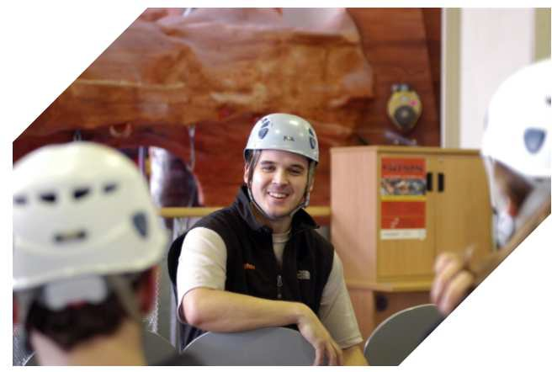

Cyberbullying occurs when someone repeatedly makes fun of another person online or repeatedly picks on another person through emails or text messages, or uses online forums with the intention of harming, damaging, humiliating or isolating another person. It can be used to carry out many different types of bullying (such as racist bullying, homophobic bullying, or bullying related to special educational needs and disabilities) but instead of the perpetrator carrying out the bullying face-to-face, they use technology as a means to do it.

# Forced marriage

This is a term used to describe a marriage in which one or both of the parties are married without their consent or against their will. A forced marriage differs from an arranged marriage, in which both parties consent to the assistance of a third party in identifying a spouse. The Anti-social Behaviour, Crime and Policing Act 2014 make it a criminal offence to force someone to marry.

# Mate Crime

A ‘mate crime’ is when ‘vulnerable people are befriended by members of the community who go on to exploit and take advantage of them (Safety Network Project, ARC). It may not be an illegal act but still has a negative effect on the individual. Mate Crime is carried out by someone the adult knows and often happens in private. In recent years there have been a number of Serious Case Reviews relating to people with a learning disability who were murdered or seriously harmed by people who purported to be their friend.

# Radicalisation

The aim of radicalisation is to attract people to their reasoning, inspire new recruits and embed their extreme views and persuade vulnerable individuals of the legitimacy of their cause. This may be direct through a relationship, or through social media.